Sprint 2: BackEnd Documentation

In this sprint we have achieved the following pertaining to backend:

1)A User can register/signup to our application: The user can sign-up to our application by giving his/her firstname, lastname, username and password.

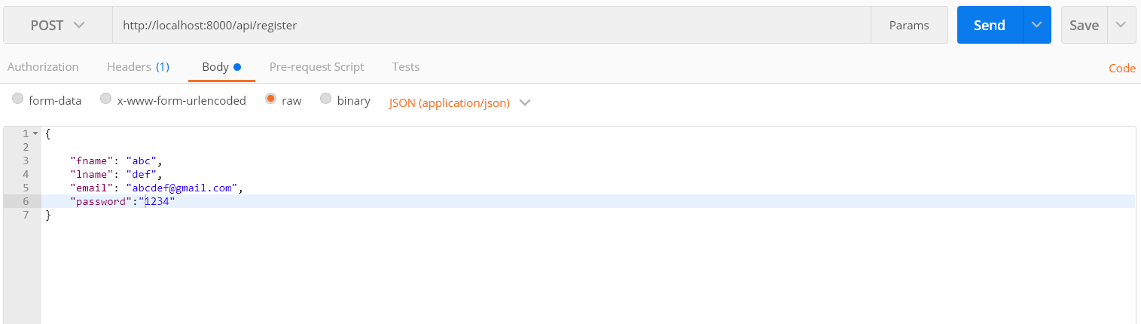

Api:http://localhost:8000/api/register

Method:Post

Status: 200->OK 404->Error

As soon as the user signs up, his data is stored in the MySQL database coonected to the server.



The database is connected with the following code.

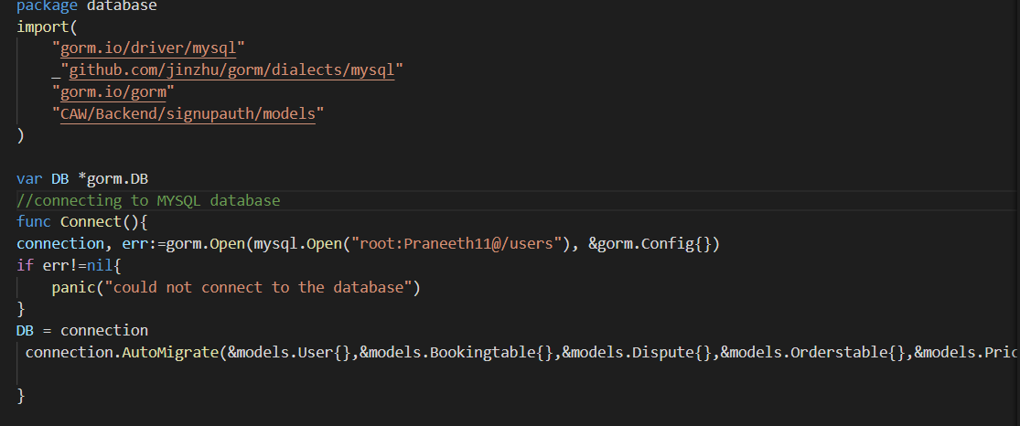

2)A registered user can login to our application. The user can provide his/her username and password that they provided during the sign-up process to login.

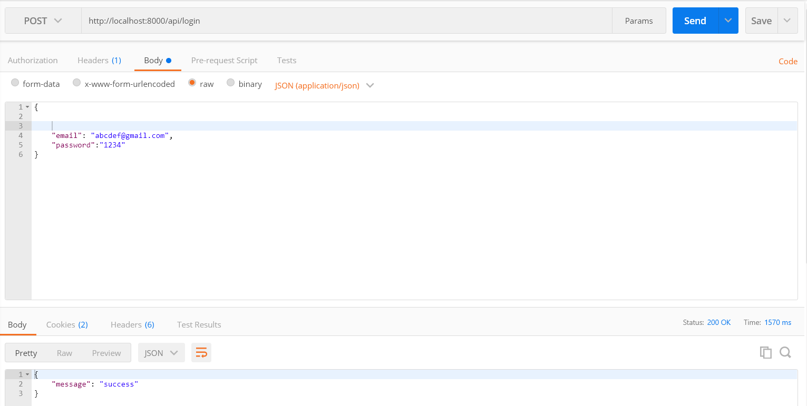

Upon successful login, a message “success” will be returned in JSON format.

Api:http://localhost:8000/api/login

Method:Post

Status: 200 OK

If the user gives a wrong password, a message called “incorrect password” will be returned in JSON format.

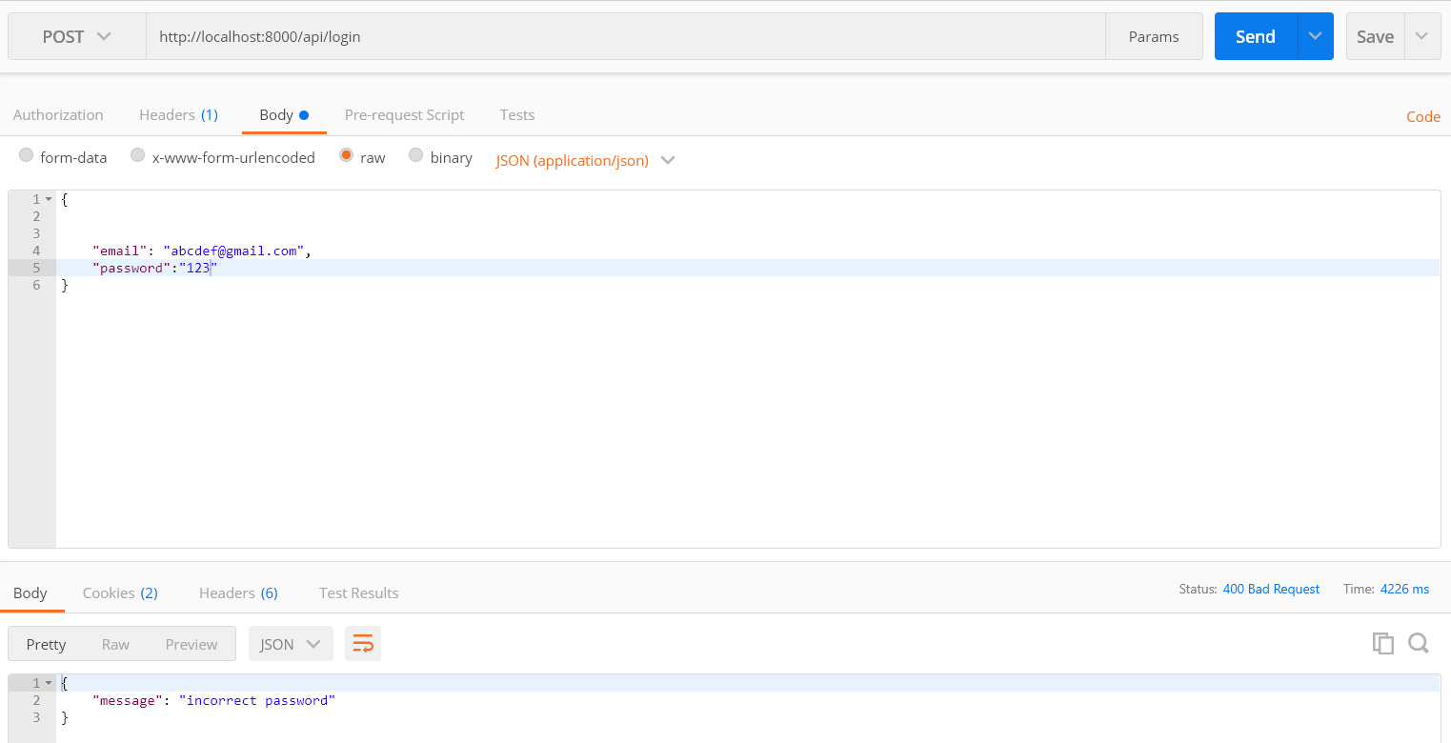

Status: 400 Bad Request

3)A list of users that are logged in can be tracked with getusers function. This can be useful for session management.

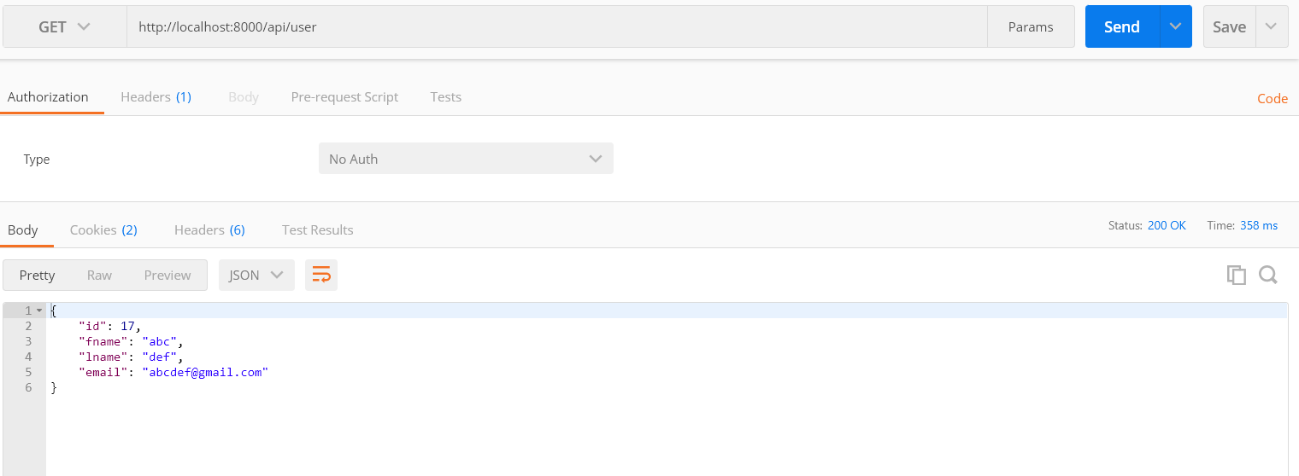

Api: <http://localhost:8000/api/user>

Method:GET

Status:200 OK

4)A user can logout of the application after his activity is done.

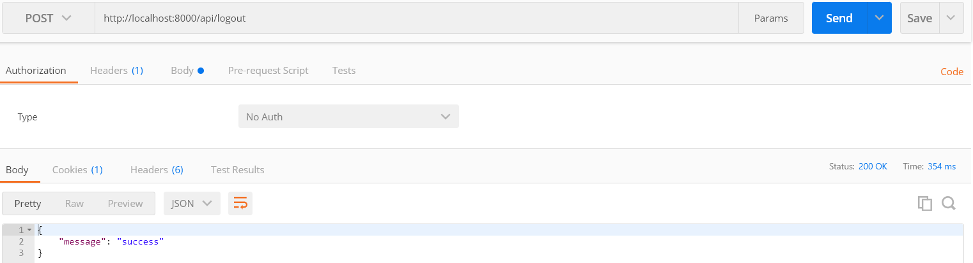

Upon successful logout a message success apperas in the form of JSON format.

Api:http://localhost:8000/api/logout

Status:200 OK

5) A password that is stored in the database is encrypted in the backend using bcrypt package. Here is an example.



6)In this sprint we have written several tests in the backend to check sign-up and sign-in functionality. The outputs are as follows:

TestSignup:

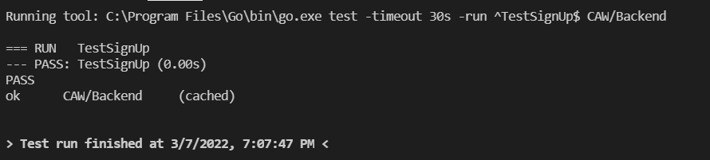

TestLogin:

